Midterm Project · Milestone 2: Baseline Linear Regression
A Baseline Linear Model for Daily Bike-Share Demand
[Your name] · [Course] · October 2026 · Analysis notebook: m2BaselineRegression.jl (Pluto)

1. Data and question
The daily file of the UCI Bike Sharing dataset (Fanaee-T, 2013; Fanaee-T & Gama, 2013) records Capital Bikeshare rentals in Washington, D.C., on 731 days in 2011–2012. The outcome is total rentals per day (cnt: mean 4,510, SD 1,933). The predictors are temperature (°C), relative humidity (%), wind speed (km/h), weather situation (clear; mist or cloudy; light rain or snow), season, year, and a day type factor (working day, weekend, holiday) that replaces the overlapping holiday, weekday and workingday flags. Weather variables were converted to physical units (temperature = −8 + 47 × temp), and season codes were relabeled because code 1 is winter. One day with an impossible 0 % humidity during rain (March 10, 2011) was removed, leaving n = 730. This baseline model is the starting point for Milestone 3, which asks whether the holiday effect is meaningful after adjusting for weather and whether it depends on temperature.

2. Building the model
A simple regression on temperature gives ŷ = 2,353.8 + 141.00·Temp (R² = 0.394). With t_{0.995, 728} = 2.583, the 99 % confidence interval for the slope is 141.0 ± 2.583 × 6.48 = (124.3, 157.7) rentals per °C. Adding the other weather and calendar terms raises R² to 0.822, but the component-plus-residual plot (Figure 1a) shows that the temperature effect is strongly curved. Polynomial terms in the centered temperature T = temperature − 20 °C fix this. The nested F-test of the linear against the cubic model (H₀: β_{T²} = β_{T³} = 0) gives F = 158.0 on 2 and 716 df (p < 0.001), while a quartic term adds nothing (p = 0.318). The cubic also has the lowest AIC, BIC and 10-fold cross-validated RMSE (Appendix Table A1).
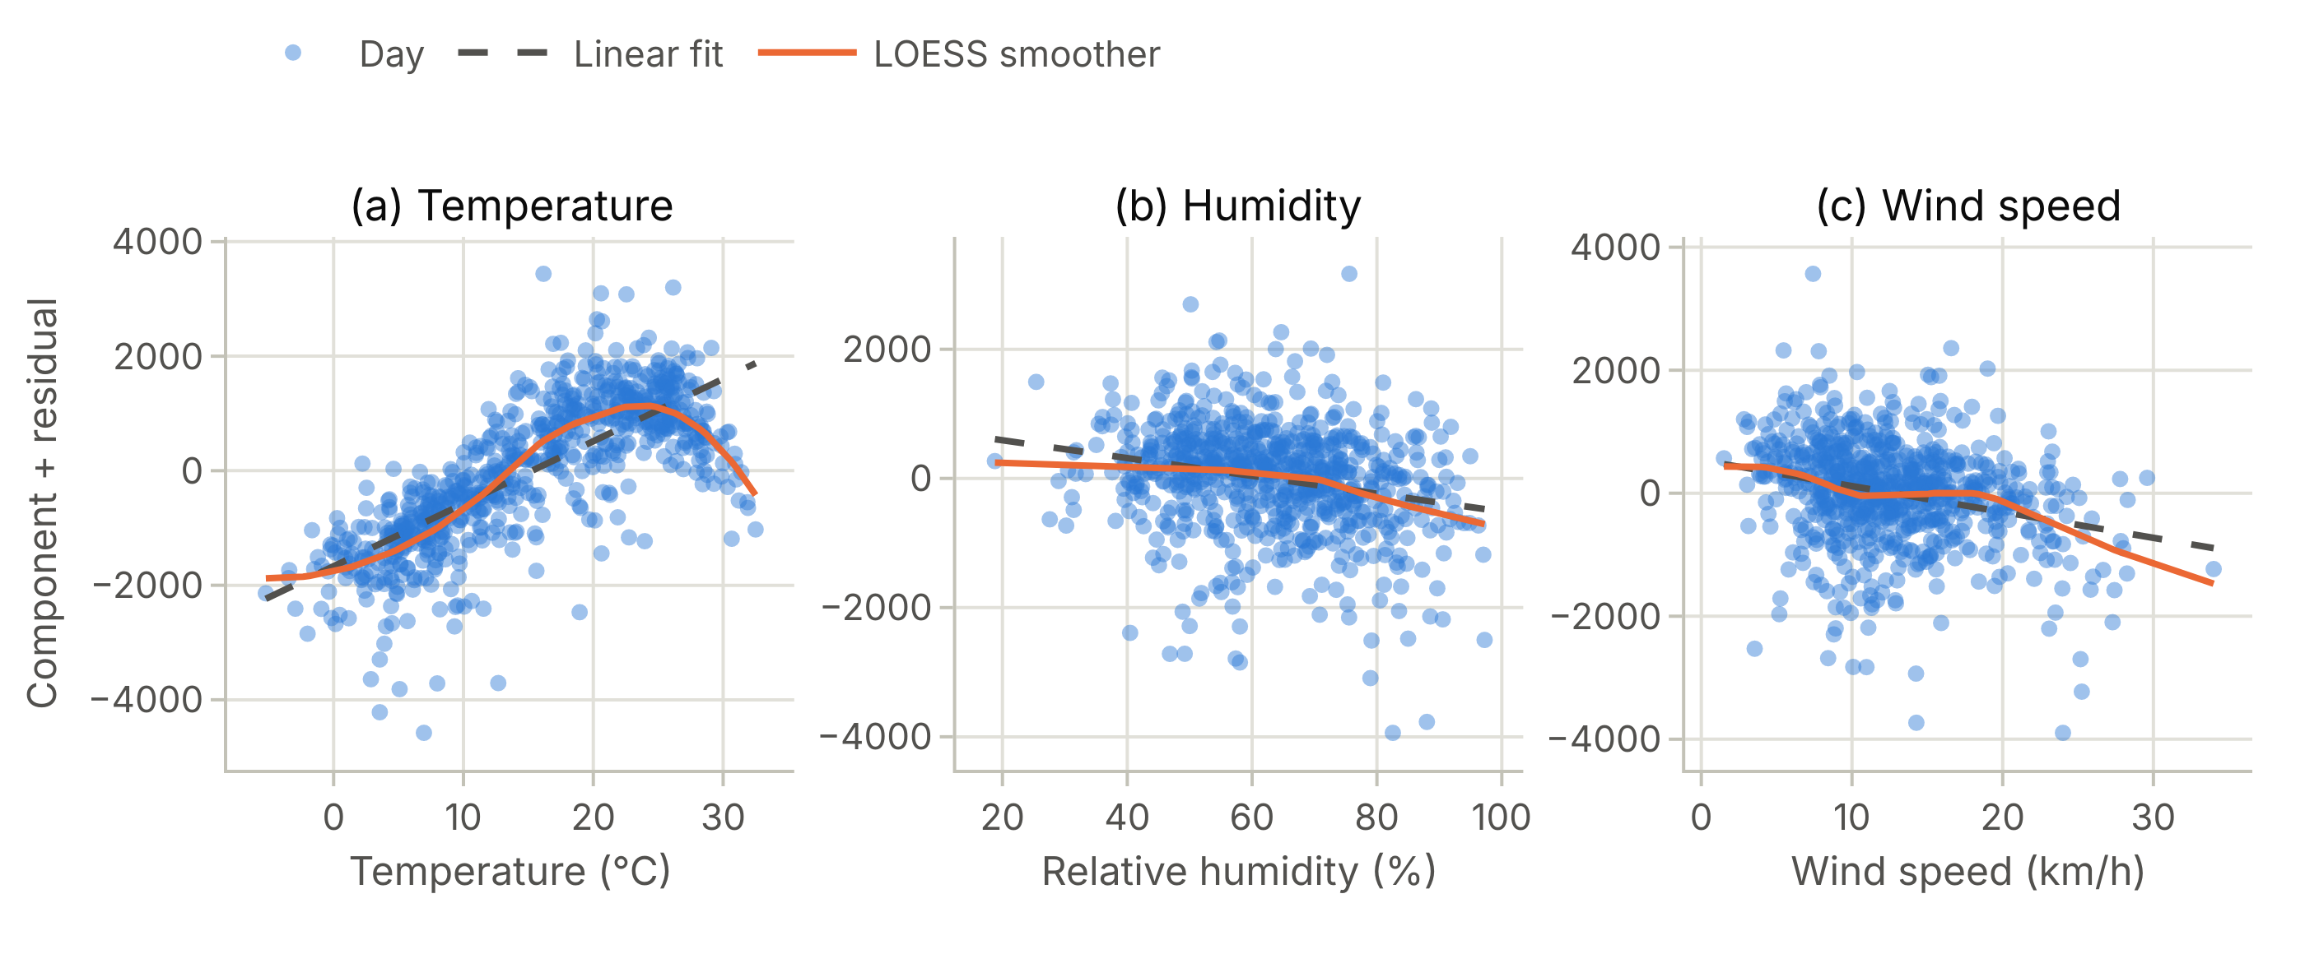
Figure 1. Component-plus-residual plots for the main-effects model with a linear temperature term. The dashed line is the fitted linear component and the orange curve a LOESS smoother; they diverge sharply for temperature (a) but not for humidity (b) or wind (c).
A full model that adds the feels-like temperature (atemp) and month shows classic multicollinearity. The standard error of the temperature term triples (7.9 → 26.4), atemp is not significant (p = 0.720), and none of the 11 month indicators are significant. The VIFs, 1/(1 − R_{j}²), are 81.1 for temperature and 72.6 for atemp (r = 0.992), and month overlaps season (generalized VIFs 797 and 176; Appendix Table A2). Backward elimination by AIC drops month, then feels-like temperature, and BIC (penalty ln 730 = 6.59) drops the same terms. Both therefore select
cnt_{i} = β₀ + β₁Yr2012_{i} + β₂Spring_{i} + β₃Summer_{i} + β₄Fall_{i} + β₅Weekend_{i} + β₆Holiday_{i} + β₇Mist_{i}
+ β₈RainSnow_{i} + β₉T_{i} + β₁₀T_{i}² + β₁₁T_{i}³ + β₁₂Hum_{i} + β₁₃Wind_{i} + ε_{i}, ε_{i} ~ iid N(0, σ²),
with each indicator compared with 2011, winter, a working day or clear weather. The model explains R² = 0.876 of the variation (adjusted 0.874; F = 390.1 on 13 and 716 df, p < 0.001), with a residual standard error of 686.1 rentals/day (Table 1).
Table 1. Final model coefficients (rentals per day), with 95 % confidence intervals estimate ± t_{0.975, 716} × SE, where t = 1.963. T = temperature − 20 °C.
Term | Estimate | SE | t | p | 95 % CI
(Intercept) | 6,243.3 | 230.5 | 27.08 | < 0.001 | (5,790.8, 6,695.9)
Year 2012 (vs 2011) | 1,953.6 | 52.03 | 37.55 | < 0.001 | (1,851.4, 2,055.7)
Spring (vs winter) | 727.9 | 97.99 | 7.43 | < 0.001 | (535.5, 920.2)
Summer (vs winter) | 985.3 | 126.9 | 7.76 | < 0.001 | (736.2, 1,234.4)
Fall (vs winter) | 1,281.2 | 85.16 | 15.05 | < 0.001 | (1,114.0, 1,448.4)
Weekend (vs working day) | −95.47 | 56.69 | −1.68 | 0.093 | (−206.8, 15.83)
Holiday (vs working day) | −618.3 | 153.4 | −4.03 | < 0.001 | (−919.4, −317.2)
Mist/cloudy (vs clear) | −371.1 | 69.08 | −5.37 | < 0.001 | (−506.7, −235.5)
Light rain/snow (vs clear) | −1,741.8 | 183.3 | −9.50 | < 0.001 | (−2,101.8, −1,381.9)
T (temperature − 20 °C) | 72.21 | 7.87 | 9.17 | < 0.001 | (56.76, 87.67)
T² | −13.72 | 0.790 | −17.36 | < 0.001 | (−15.27, −12.17)
T³ | −0.481 | 0.040 | −12.07 | < 0.001 | (−0.559, −0.403)
Humidity (%) | −23.76 | 2.65 | −8.96 | < 0.001 | (−28.97, −18.56)
Wind speed (km/h) | −51.79 | 5.41 | −9.57 | < 0.001 | (−62.41, −41.17)

3. Checking the assumptions
- Linearity. The cubic component tracks the temperature partial residuals (Appendix Figure A1), and humidity and wind are close to linear. Squared terms for them are detectable (F = 16.5, p < 0.001) but add only 0.005 to R², so the interpretable linear terms are kept. The residual smoother (Fig. 2a) is flat except at the low end. On the 26 days with fitted values below 1,000 (cold, wet or windy days) the model under-predicts by 716 rentals on average, and 3 fitted values are negative, because an additive model cannot respect the floor at zero.
- Constant variance. Otherwise there is no fan shape: the residual SD is 662, 663 and 698 across thirds of the fitted values, and a studentized Breusch–Pagan test (Koenker, 1981) against the fitted values finds nothing (p = 0.896). Against all predictors the test rejects (LM = 75.2, 13 df, p < 0.001) because 2012 residuals are more variable (SD 782 vs 560).
- Normality. The Q–Q plot has a heavy left tail (skewness −0.78, excess kurtosis 3.09; Shapiro–Wilk W = 0.951, p < 0.001) (hurricanes, holidays). With n = 730, coefficient inference is robust to this, but single-day prediction intervals are less so.
- Leverage and influence. 53 days exceed the 2p/n = 0.038 leverage flag, and 41 of them are rain or snow days or holidays (rare categories of 21 days each). The highest leverage (h = 0.133) belongs to the coldest day (−5.2 °C), whose residual is small. The largest Cook's distance is 0.112 (Hurricane Sandy), far below 0.5 (Appendix Table A3), and refitting without the two Sandy days moves no significant slope by more than 8 %.
- Independence. Residuals are positively autocorrelated (lag-1 r = 0.31, Durbin–Watson = 1.39), with smaller peaks at lags 7 and 14 (Fig. 2e–f), pointing to multi-day weather spells and a day-of-week pattern. Newey–West (1987) standard errors are 1.0–1.6 times the OLS values, and every coefficient significant at 5 % stays significant (Appendix Table A4).
- Multicollinearity. Without atemp and month, every GVIF^{1/(2·df)} (Fox & Monette, 1992) is ≤ 1.47.
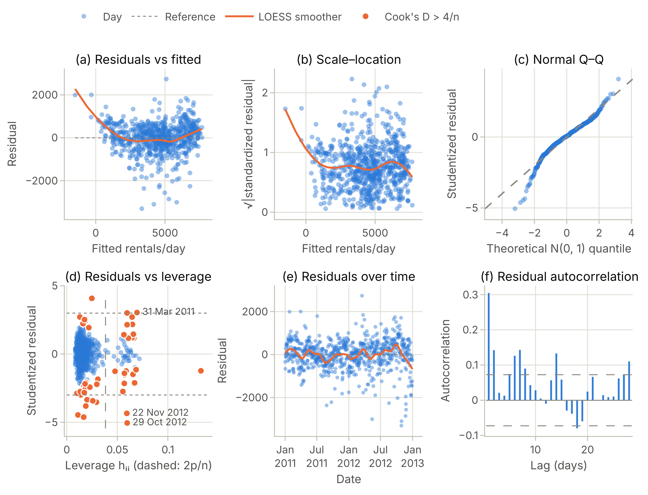
Figure 2. Diagnostics for the final model: (a) residuals vs fitted values and (b) scale–location, with LOESS smoothers; (c) normal Q–Q plot of studentized residuals; (d) studentized residuals vs leverage, with days whose Cook's distance exceeds 4/n in orange (dashed line: 2p/n); (e) residuals over time; (f) residual autocorrelation with ±1.96/√n bounds.

4. Interpreting the key coefficients
Figure 3 shows effect displays (Fox & Weisberg, 2019): predicted rentals as one predictor varies and the others stay at their sample averages (factors at their observed mix). Each statement holds the other predictors constant.
- Temperature (panel a). The linear coefficient, 72.2 (95 % CI 56.8 to 87.7), is the slope at 20 °C. Predicted rentals rise by 159–202 per degree between 5 °C and 15 °C and peak at 22.3 °C (72 °F), about 5,687 rentals on an average day. Beyond the peak they fall, and a 30 °C day has 1,218 fewer rentals than a day at the peak.
- Humidity (−23.76 per point; panel b). Each additional percentage point of humidity means about 24 fewer rentals (95 % CI 18.6 to 29.0), or 238 fewer per 10 points.
- Wind (−51.79 per km/h; panel c). A 10 km/h windier day has 518 fewer rentals (95 % CI 412 to 624).
- Precipitation (panel d). Light rain or snow costs about 1,742 rentals relative to an otherwise identical clear day (95 % CI 1,382 to 2,102). Mist or cloud costs about 371.
- Holiday (panel e). For H₀: β_{Holiday} = 0, t = −618.3/153.4 = −4.03 on 716 df (p < 0.001), so we reject H₀. Holidays average 618 fewer rentals than comparable working days (95 % CI 317 to 919). Weekends do not differ significantly from working days (t = −1.68, p = 0.093). The largest single effect is system growth: 2012 averages 1,954 more rentals per day than 2011 (panel f).
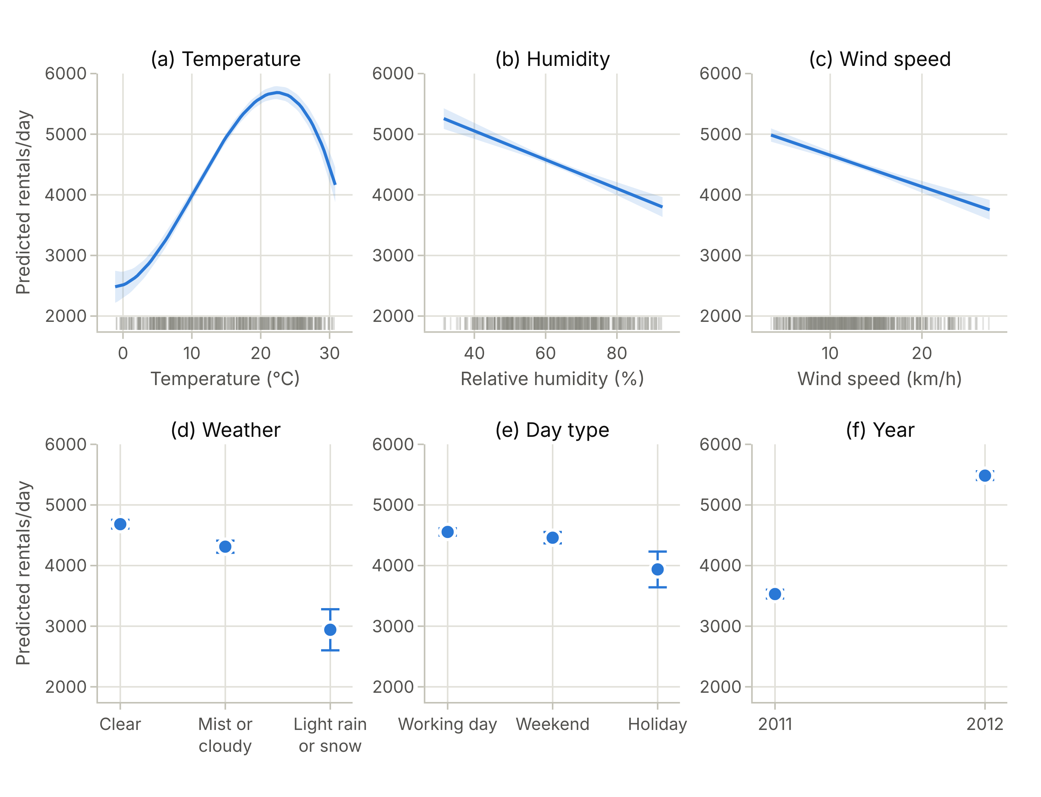
Figure 3. Partial effects from the final model with 95 % confidence bands or bars. Curves cover the central 98 % of observed values; ticks mark the observed days.
Prediction. For Thanksgiving 2012 (clear, 8.0 °C) the model predicts ŷ₀ = 5,282 rentals. With x₀^{T}(X^{T}X)⁻¹x₀ = 0.0594, the 95 % prediction interval for a new day like it is 5,282 ± 1.963 × 686.1√(1 + 0.0594) = (3,895, 6,668). The interval for the mean response is (4,953, 5,610). Only 2,425 bikes were rented (residual −2,857), while the warm Independence Day 2011 (26.2 °C) was under-predicted by 1,790. This suggests that the holiday effect depends on temperature, which Milestone 3 will test.

5. Conclusions and next steps
Holding season, year and the other weather variables fixed, demand peaks near 22 °C, rain or snow costs about 1,742 rentals, and holidays average 618 fewer rentals than working days. The cubic term resolves the main linearity problem, no day is unduly influential, and the conclusions survive robust standard errors. Three problems remain: autocorrelated errors with more variance in 2012, a heavy left tail, and under-prediction of the slowest days, with negative fitted counts (minimum −1,487). These problems, together with the multiplicative growth, motivate a Poisson or negative-binomial GLM in the final project. Milestone 3 will use day type as the treatment in an ANCOVA with these covariates and add a holiday × temperature interaction.

References
Fanaee-T, H. (2013). Bike Sharing [Dataset]. UCI Machine Learning Repository. https://doi.org/10.24432/C5W894
Fanaee-T, H., & Gama, J. (2013). Event labeling combining ensemble detectors and background knowledge. Progress in Artificial Intelligence, 1–15. https://doi.org/10.1007/s13748-013-0040-3
Fox, J., & Monette, G. (1992). Generalized collinearity diagnostics. Journal of the American Statistical Association, 87(417), 178–183.
Fox, J., & Weisberg, S. (2019). An R companion to applied regression (3rd ed.). Sage.
Koenker, R. (1981). A note on studentizing a test for heteroscedasticity. Journal of Econometrics, 17(1), 107–112.
Newey, W. K., & West, K. D. (1987). A simple, positive semi-definite, heteroskedasticity and autocorrelation consistent covariance matrix. Econometrica, 55(3), 703–708.

Appendix: additional tables and diagnostics
All results are produced by the Pluto notebook m2BaselineRegression.jl (Julia 1.12.7), with a static HTML export m2BaselineRegression.html in the same folder. The notebook's sections follow the Exam 1 review template: model statement and confidence interval (§2), coefficient and nested-model tests (§3–4), multicollinearity and VIF (§5), backward AIC/BIC (§6), and inference, prediction and residual diagnostics (§7–8).
Table A1. Model comparison. AIC and BIC are log-likelihood based; CV RMSE is the root-mean-squared error from 10-fold cross-validation (same folds for all models).
Model | Parameters | R² | Adj. R² | Residual SE | AIC | BIC | CV RMSE
Temperature only (simple regression) | 2 | 0.394 | 0.393 | 1,505.8 | 12,758.6 | 12,772.4 | 1,506.4
Main effects, linear temperature | 12 | 0.822 | 0.819 | 822.6 | 11,885.7 | 11,945.4 | 828.6
Main effects + T² | 13 | 0.851 | 0.849 | 752.2 | 11,756.1 | 11,820.4 | 760.7
Main effects + T² + T³ (final) | 14 | 0.876 | 0.874 | 686.1 | 11,622.8 | 11,691.7 | 696.6
Main effects + T² + T³ + T⁴ | 15 | 0.876 | 0.874 | 686.1 | 11,623.8 | 11,697.3 | 697.1
Final + feels-like temperature + month | 26 | 0.880 | 0.875 | 682.5 | 11,626.8 | 11,750.8 | 708.3
Sequential F-tests: linear → quadratic F = 141.7 (p < 0.001); quadratic → cubic F = 145.7 (p < 0.001); cubic → quartic F = 1.00 (p = 0.318).
Table A2. Multicollinearity in the full model (final model + feels-like temperature + month). For factors, the generalized VIF and GVIF^{1/(2·df)} (comparable to √VIF) are shown; for single-column terms GVIF = VIF.
Term | df | GVIF | GVIF^{1/(2·df)}
Year | 1 | 1.06 | 1.03
Season | 3 | 176.18 | 2.37
Month | 11 | 796.74 | 1.35
Day type | 2 | 1.05 | 1.01
Weather | 2 | 2.01 | 1.19
T (temperature − 20 °C) | 1 | 81.10 | 9.01
T² | 1 | 16.52 | 4.06
T³ | 1 | 17.23 | 4.15
Feels-like temperature | 1 | 72.60 | 8.52
Humidity | 1 | 2.33 | 1.53
Wind speed | 1 | 1.30 | 1.14
Table A2b. Backward elimination path. The criteria are computed as in R's step(): n ln(RSS/n) + k·p with k = 2 (AIC) or k = ln n (BIC). At the final step no deletion lowers either criterion. Removing day type would raise BIC by only 4.7.
Step | AIC | BIC
Start (full model) | 9,553.17 | 9,672.59
Drop month | 9,551.04 | 9,619.93
Drop feels-like temperature | 9,549.19 | 9,613.49
Table A3. The eight days with the largest Cook's distance in the final model.
Date | Day type | Weather | Rentals | Fitted | Stud. resid. | Leverage | Cook's D | What happened
Mon 29 Oct 2012 | Working day | Light rain/snow | 22 | 3,327 | −5.05 | 0.060 | 0.112 | Hurricane Sandy: system nearly shut down
Thu 22 Nov 2012 | Holiday | Clear | 2,425 | 5,282 | −4.35 | 0.059 | 0.083 | Thanksgiving
Thu 31 Mar 2011 | Working day | Light rain/snow | 1,685 | −316 | 3.04 | 0.069 | 0.049 | Cold, wet day; fitted value is negative
Wed 26 Jan 2011 | Working day | Light rain/snow | 506 | −1,487 | 3.01 | 0.060 | 0.041 | Snowstorm; fitted value is negative
Mon 4 Jul 2011 | Holiday | Mist/cloudy | 6,043 | 4,253 | 2.71 | 0.065 | 0.036 | Independence Day
Thu 24 Nov 2011 | Holiday | Clear | 1,495 | 3,316 | −2.74 | 0.056 | 0.031 | Thanksgiving
Sat 17 Mar 2012 | Weekend | Mist/cloudy | 7,836 | 5,099 | 4.08 | 0.025 | 0.030 | Warm Saturday, St. Patrick's Day
Sat 27 Aug 2011 | Weekend | Mist/cloudy | 1,115 | 3,480 | −3.53 | 0.029 | 0.026 | Hurricane Irene
Table A4. Standard errors under three assumptions: OLS (independent, constant variance), HC3 (heteroscedasticity-consistent) and Newey–West (heteroscedasticity- and autocorrelation-consistent, Bartlett kernel, 6 lags), with estimates refitted without the two Hurricane Sandy days (29–30 October 2012).
Term | Estimate | SE (OLS) | SE (HC3) | SE (Newey–West) | p (Newey–West) | Without Sandy
(Intercept) | 6,243.3 | 230.5 | 249.3 | 269.6 | < 0.001 | 6,116.3
Year 2012 (vs 2011) | 1,953.6 | 52.03 | 53.87 | 71.67 | < 0.001 | 1,979.4
Spring (vs winter) | 727.9 | 97.99 | 104.8 | 127.3 | < 0.001 | 741.6
Summer (vs winter) | 985.3 | 126.9 | 128.7 | 163.6 | < 0.001 | 1,001.0
Fall (vs winter) | 1,281.2 | 85.16 | 96.45 | 136.6 | < 0.001 | 1,323.5
Weekend (vs working day) | −95.47 | 56.69 | 61.41 | 61.42 | 0.121 | −108.9
Holiday (vs working day) | −618.3 | 153.4 | 244.3 | 220.5 | 0.005 | −630.8
Mist/cloudy (vs clear) | −371.1 | 69.08 | 64.93 | 68.66 | < 0.001 | −372.4
Light rain/snow (vs clear) | −1,741.8 | 183.3 | 289.0 | 254.6 | < 0.001 | −1,608.2
T = temperature − 20 °C | 72.21 | 7.87 | 7.18 | 8.13 | < 0.001 | 72.02
T² | −13.72 | 0.790 | 0.728 | 0.914 | < 0.001 | −13.51
T³ | −0.481 | 0.040 | 0.037 | 0.042 | < 0.001 | −0.474
Humidity (%) | −23.76 | 2.65 | 2.65 | 2.73 | < 0.001 | −22.85
Wind speed (km/h) | −51.79 | 5.41 | 6.47 | 6.34 | < 0.001 | −48.92

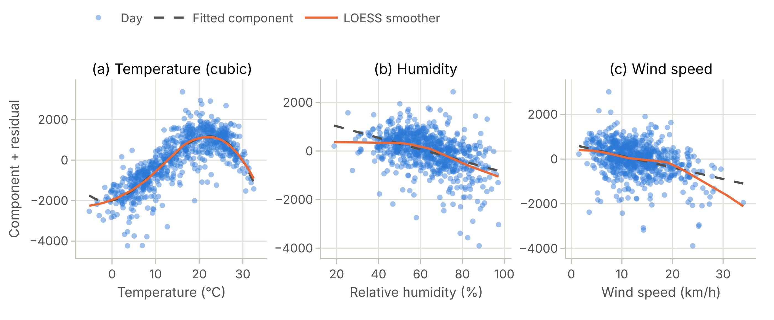
Figure A1. Component-plus-residual plots for the final model. With the cubic term, the LOESS smoother (orange) follows the fitted temperature component (dashed). Humidity and wind are close to linear, with mild curvature at the extremes.

